

Programme | : | M.Tech Int Software Engineering | Semester | : | Fall 2026-2027
Course | : | Database Systems Lab | Code | : | IASWE206
Faculty | : | Dr. M. Premalatha | Slot | : | L31+L32

Ex. No. 6
Date: 24-08-2026
SQL Subqueries – Set Operations

Note:
LMS Submission Format [Word File]
Regno, name
Course code, course title
Slot
Faculty Name
Question
SQL Query – Text Format (Copy Paste)
Screenshot

Ex:
Question:
create a student table with attributes regno, name, mobno and dob with appropriate datatypes and sizes

Query:
SQL> create table student_mp(regno varchar(4), sname char(10), mobno number(10), dob date);
Table created.

Screenshot:

SQL> desc student_mp
Name Null? Type
----------------------------------------- -------- ------------
REGNO VARCHAR2(4)
SNAME CHAR(10)
MOBNO NUMBER(10)
DOB DATE
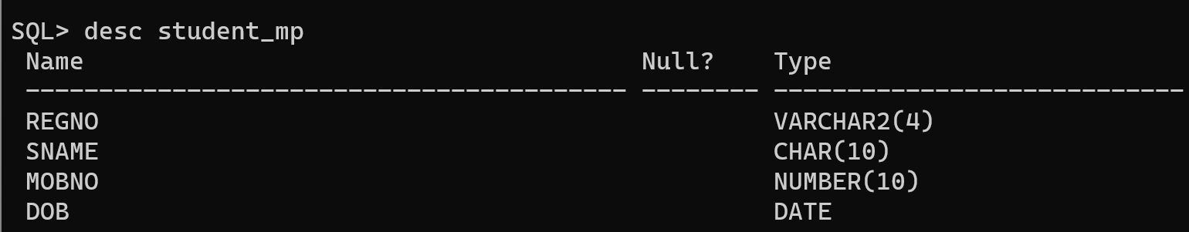

student(regno, sname, cgpa, school)
course(ccode, cname, credits)
faculty(empid, fname, designation, salary)
course_student(regno, ccode)
course_faculty(fid, ccode)

From the already created tables with key constraints of the above specified schema, write the SQL queries for the following:
Subquery Questions
- Display the names of students who have the highest CGPA in the entire college (using a subquery).
- List the details of students whose CGPA is greater than the average CGPA of all students.
- Find the names of faculty members who earn more than the average salary of all faculty.
- Display the course names of courses that have not been assigned to any faculty (using NOT IN / NOT EXISTS).
- List the students who are enrolled in the course with course code 'C101' (using a subquery on course_student).
- Find the faculty member(s) who have the highest salary in each designation (using a correlated subquery).
- Display the names of students who have not enrolled in any course (using NOT EXISTS).
- List the course names for which the number of students enrolled is greater than the average number of students enrolled per course.
- Find the second highest CGPA among students (using a subquery with LIMIT/TOP or MAX).
- Display the names of courses taught by faculty whose designation is 'Professor' (using a nested subquery joining course_faculty and faculty).
Built-in Function Questions
- Display the student name in uppercase along with the length of the student name (using UPPER() and LENGTH()/LEN()).
- Find the total number of students in each school, and the average CGPA of each school, rounded to 2 decimal places (using COUNT(), AVG(), and ROUND()).
- Display the faculty name and salary, formatted so the salary is shown with a currency symbol and the designation converted to lowercase (using CONCAT() and LOWER()).
- Find the maximum, minimum, and average number of credits among all courses (using MAX(), MIN(), and AVG()).
- Display the first three characters of each student's name and the current date when the query is run (using SUBSTRING()/SUBSTR() and CURDATE()/SYSDATE()/GETDATE()).

